Q6 Create a simple cloud software application for Payroll Processing System using any Cloud Service Provider to demonstrate SaaS include the necessary fields such as Name of the employee, experience in present org , over all experience, basic pay, HRA, DA, TA, net pay, gross pay etc

# CREATING AN EMPLOYEE DETAILS  
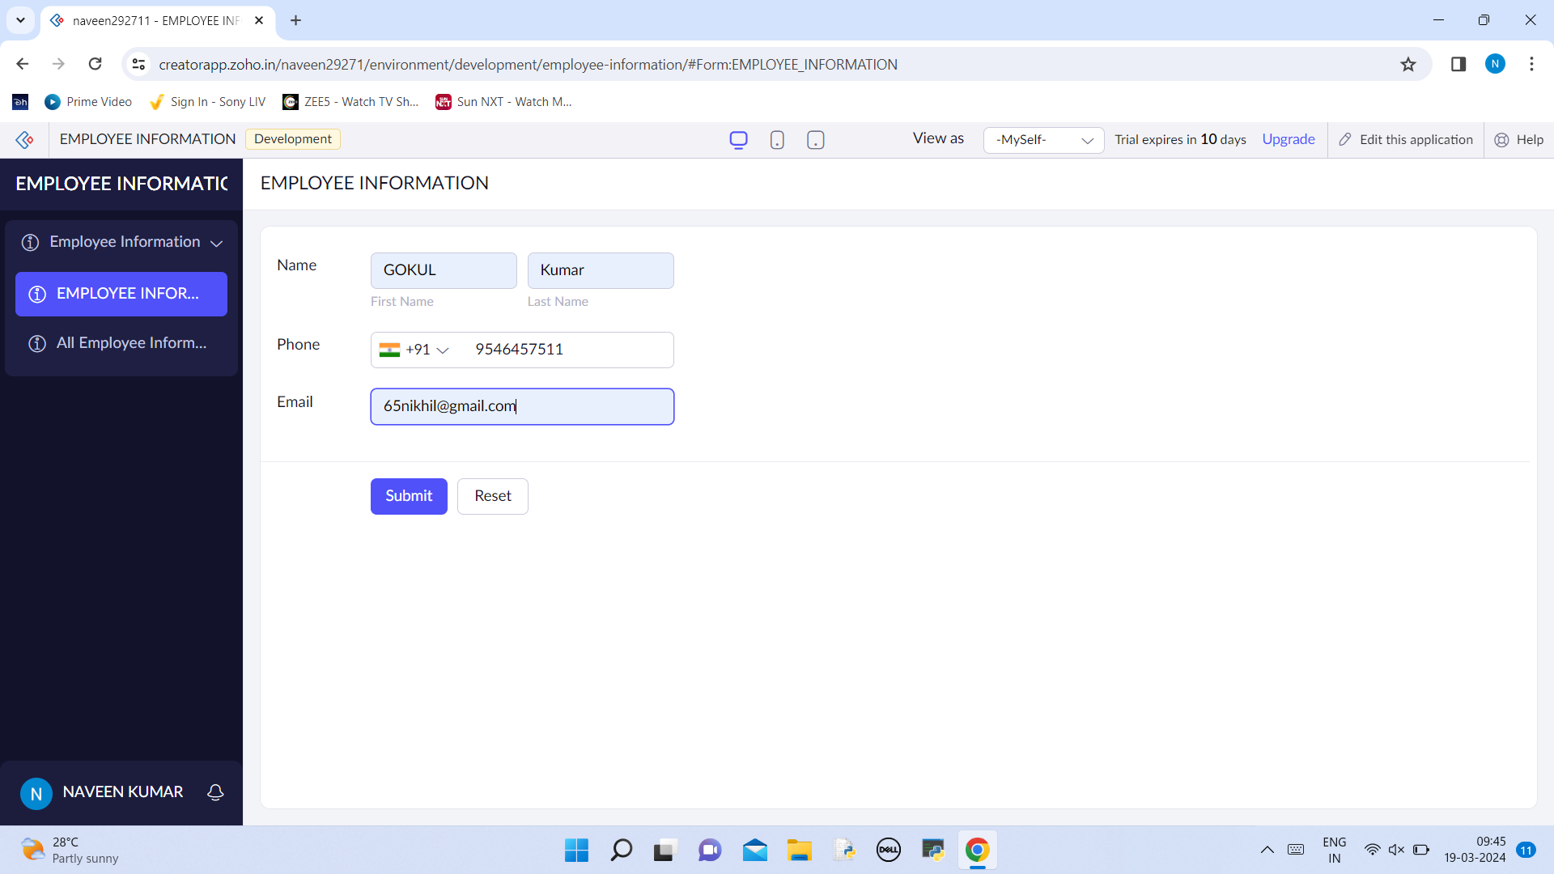

# DISPLAYING THE EMPLOYEE DETAILS  
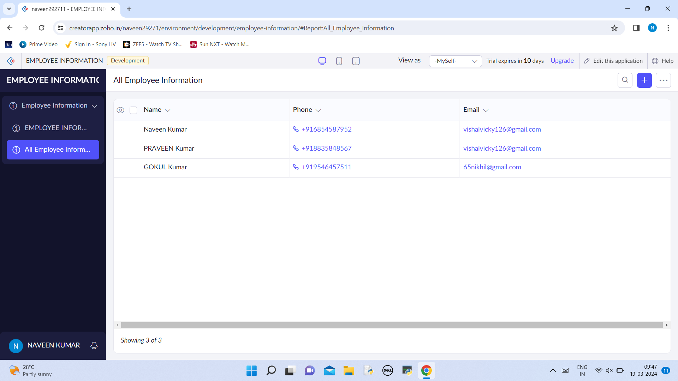

# CREATING EMPLOYEE SALARY DETAILS   
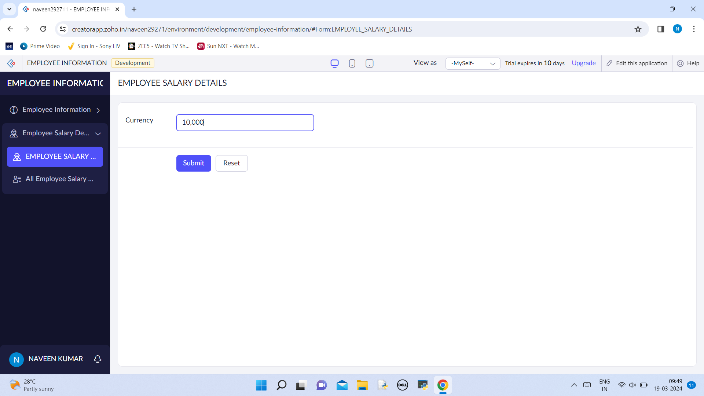

# DISPLAYING THE SALAYRY DETAILS   
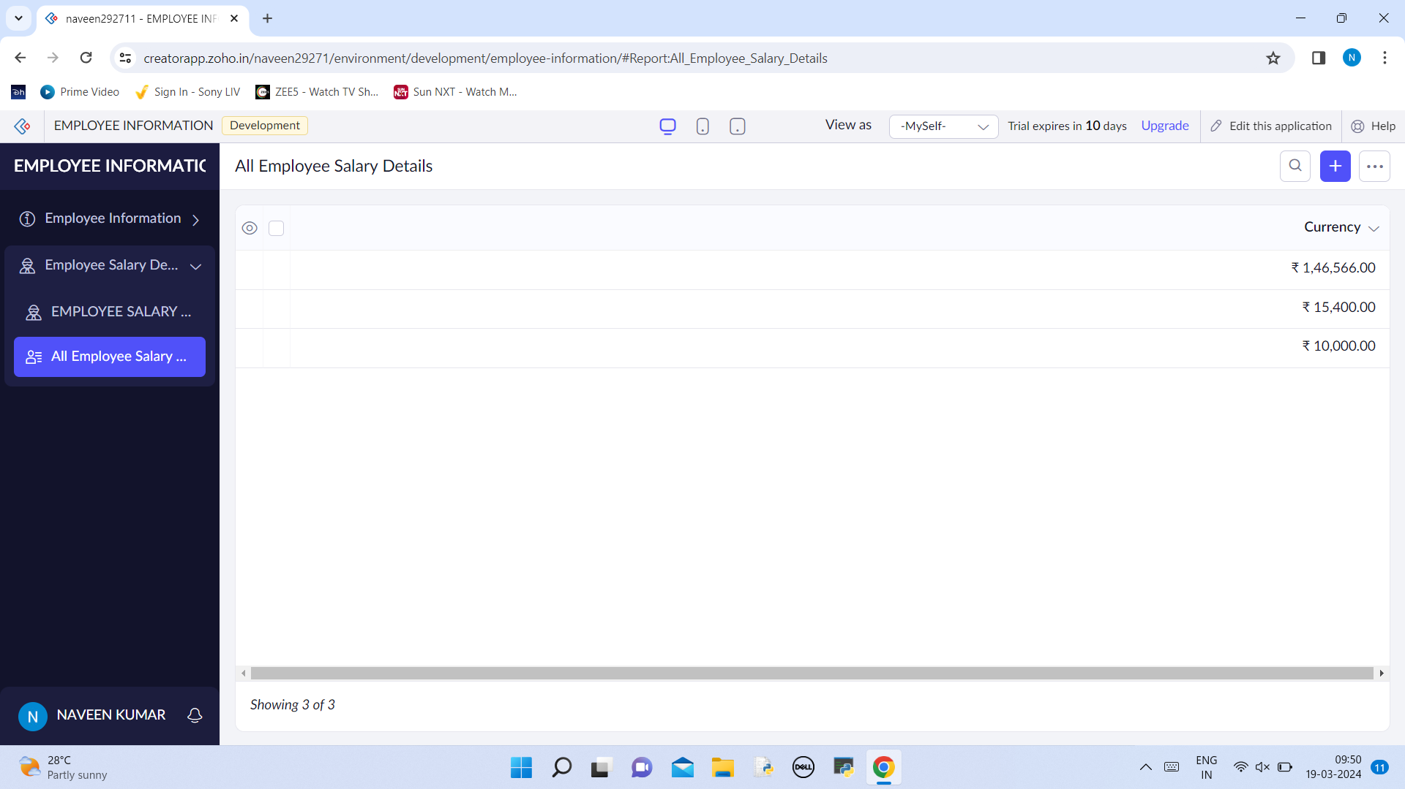

# CREATING THE TAX DEDUCTION   
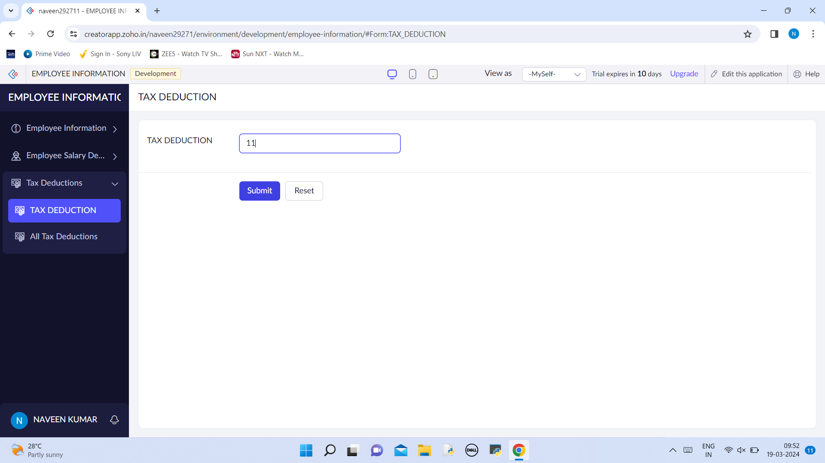

# LISTING THE TAX DETECTION LIST  
